**Smart Water Fountain**

**Phase 3**

**NAME : Peyyala Naganandhini**

**NMID : au723921106012**

**EMAIL : peyyalanaganandini9550@gmail.com**

# Introduction

***1.1 Objective:***

Today, more people around the world have pets than ever before. According to American Pet Products Association’s survey in 2020, 67% of U.S. households own a pet which is about 84.9 million homes. This proportion has been increased by 20% in thirty years [1]. Breakdown of the pet types, cats and dogs are the most popular animals, they contribute to about 80% of all pets. Same trend happens all over the world. On average, one in three households own a dog globally and about a quarter of households worldwide own a cat [2]. Both cats and dogs prefer flowing water. A source of fresh clean running water can encourage pets to drink. Drinking a certain amount of water daily plays an important role in long-term health for pets, especially cats. As a result, a water fountain is essential to most households having cats or dogs as pets. However, we can not ensure the water quality when we are away from home for several days. It can happen when pets have finished all remaining water in the water fountain, or water has been polluted somehow by the pet.

These can cause the pet to be unwilling to drink water from the fountain.

Our goal is to design a smart water fountain that can monitor the water quality and automatically replace water when polluted(not healthy) or running out. We will use sensors to measure the water quality. Common water quality measurement factors include temperature, Ph-value, conductance, turbidity and hardness [3]. Considering the pollution at home can only affect limited factors, we choose temperature, Ph-value and conductance to be the three properties used for calculating water quality in our water fountain. These data will be collected, calculated, and reflected to the user in terms of “Good”, “Average” and

“Bad”. The water fountain is also designed to self-filter the water every time when water is pumped through the submersible water pump.

***1.2 Background:***

There have been quite a lot of water fountain products on the market[4], while most of them have only filtration as an extra function besides providing running water. [5] The size of the water fountain limits the capacity of the water source that most water fountains cannot store enough water for multiple pets to drink in several days.

Our water fountain can be connected to an extra water source that provides enough water for long-term usage. The link is adaptable to universal water bottles for convenience. The sufficient water source as well as automatic replacing and refilling function enable pet owners to leave home for several days without worrying about water supply for pets.

**1.3  *Physical Design*:**

A pictorial representation of your project that puts your solution in context. Not necessarily restricted to your design. Include other external systems relevant to your project (e.g. if your solution connects to a phone via Bluetooth, draw a dotted line between your device and the phone). Note that this is not a block diagram and should explain how the solution is used, not a breakdown of inner components.

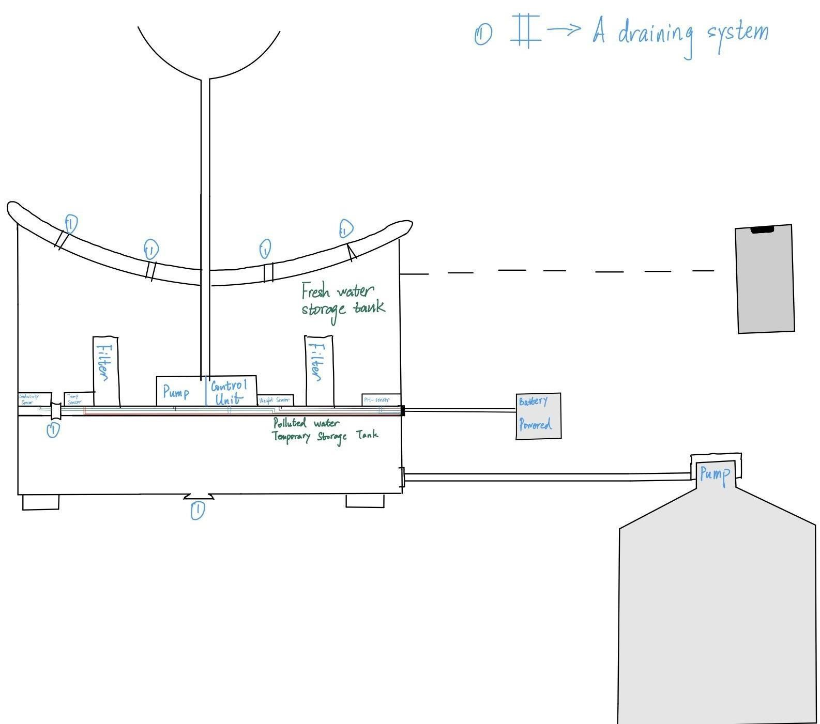

*Figure 1 Smart Fountain Physical Diagram*

***1.4 High-level requirements list:***

* Able to drain the polluted water and replace it with fresh water. Specifically, the polluted water will be drained by a motor-controlled valve to the “polluted water temporary storage tank” part. After completing the draining process, fresh water will be pumped from the general water supply(as described in the right down corner of the physical design, Figure

1).

* The fountain must accurately monitor the water quality, including measuring water temperature up to 48.89C and pH values between 6.5 and 8.5.
* Able to be connected to the users’ devices through WIFI. Prompt feedback from the smart water fountain to users’ interface with relevant information including the remaining water level and water quality index: ‘Good’, ‘Average’ and ‘Poor’.

# Design

The block diagram below is a general design of our solution. We divide our design into four modules, including Power Supply, Control Unit, External Control, and Mechanical Unit.

Details of each unit is presented in the diagram and described in the next section.

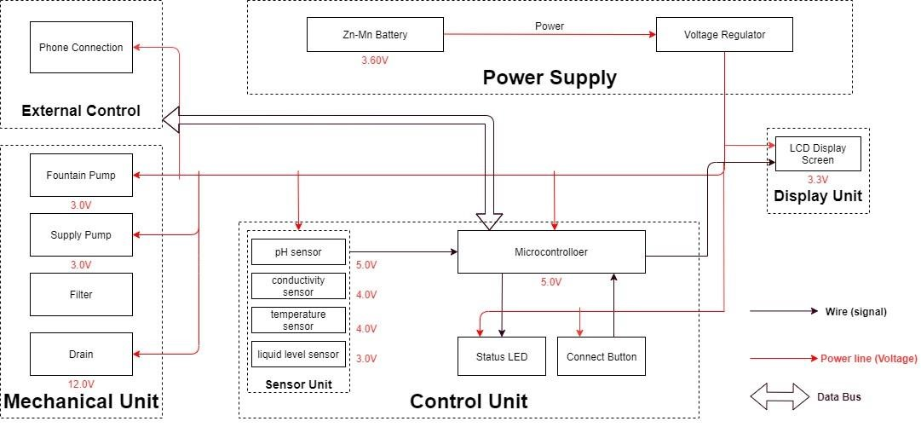

*Figure 2 Block Diagram of Smart Water Fountain*

***2.1 Sensor Unit***

This block contains the four sensors. The data acquired from the sensors will be transmitted to the control unit. Control unit will then have some logic designed to send corresponding signals to control other blocks of the water fountain. At the same time, the display screen on the water fountain will display the readings along with the determined water quality level and remaining water quantity.

For the PH-value sensor, temperature sensor and conductivity sensor, values will be retrieved and calculated to determine the overall water quality level. When poor water quality is determined, the water replacement procedures will take place. The weight sensor readings will be used to determine the amount of fresh water left in the water tank.

**2.1.1 Temperature Sensor:**

A water-proof temperature sensor is going to be used. Part number from sparkfun is: DS18B20 [6]. This temperature sensor is compatible with a relatively wide range of power supply from 3.0V to 5.5V. The measured temperature ranges from -55 to +125 celsius degrees. Between -10 to + 85 degrees, the accuracy is up to +-0.5 degrees. This sensor can fulfill all requirements needed for this project.

**2.1.2 PH-sensor:**

PH value is a valued indicator of water quality. This PH-sensor[7] works with 5V voltage, which is also compatible with the temperature sensor. It can 6measure the PH value from 0 to 14 with an accuracy of +- 0.1 at the temperature of 25 degrees.

**2.1.3 Conductivity sensor:**

Conductivity sensor is also part of the water quality assessment. The input voltage is from 3.0 to 5.0V. The error is small, +-5%F.S. The measurement value ranges from 0 to 20 ms/cm which is enough for water quality monitoring. [8]

**2.1.4 Liquid Level Sensor:**

This sensor [9] is responsible for reflecting how much freshwater is left in the water tank. When the water level is low, fresh water will be pumped to the water tank to ensure the water fountain keeps running with freshwater. This sensor is 0.5 Watts. For water level from 0 to 9 inches, the corresponding sensor outputs readings from 0 to 1.6. From that, the quantity of freshwater left can be determined.

***2.2 Display unit:***

**2.2.1 Screen:**

The screen will be used to display the readings from the sensors in a real-time manner.[10] In addition, other necessary information will also be displayed. As described in the sensor part, the water quality and remaining water quantity will be displayed. The screen will be programmed so that it makes it easy for users to read information.

This 20*4 LCD display screen is going to be used to display the relevant information. After programming the screen, a conclusion of water quality(Good, Average, Poor) will be displayed along with the remaining water level.

***2.3 Power Supply Unit***

**2.3.1 Zn-Mn Battery**

The Zn-Mn battery must be able to continuously support the functioning of the circuit, display unit, and the mechanical unit.

Requirement: Commercial batteries will be used to maintain a continuous 3.60V power supply for at least 24 hours. If the chosen battery is not powerful enough, 120V power outlets will be considered.

**2.3.2 Voltage regulator**

The integrated circuit will regulate the power supply for each module to maintain their functionality. This chip must be able to handle the maximum voltage supplied by the battery (3.60V ± 0.5V) while ensuring the voltage at each module does not exceed their limit.

Requirement: Must maintain thermal stability below 100°C.

***2.4 Mechanical Unit***

**2.4.1 Fountain Pump**

The fountain pump [14] must maintain a continuous water supply through the fountain mechanism. The pump must work 24 hours a day, 7 days a week unless the user manually turns off the power supply.

Requirement 1: The fountain pump must lift a cylindrical water stream of diameter 6mm for a height of 400mm.

Requirement 2: The fountain pump must serve for a duration of 2 years without maintenance or replacement under heavy workload.

Requirement 3: The fountain pump should have an operational condition around 3V, 200mA.

**2.4.2 Supply Pump**

The supply pump must function when a low water level alert is raised. While no water supply is requested, the pump must prevent water flow between the main supply and the fountain.

Requirement: The supply pump should have an operational condition around 3V, 200mA.

**2.4.3 Filter**

The filter must maintain the water quality through controlling the pH value and conductivity of the water.

Requirement 1: The filter must have a cost less than $5 each for frequent replacement. Each new filter must serve a duration no less than 3 month.

Requirement 2: The filter must be designed for easy removal and installation, while the connection mechanism must have a low degenerate rate when submerged in water.

**2.4.4 Drain**

The drain [13] must be able to hold and release water in the fountain. When water in the fountain should be replaced, the faucet should automatically drain the fountain once instruction is received from the integrated circuit.

***2.5 Control Unit***

This unit contains the control unit which does the following things:

* When the weight sensor reports a weight less than the minimum weight setting, the control unit will send an alert signal to the user and then control the water supply unit to refill the water fountain with a certain amount of water.
* Computes the water quality with data transferred from the three sensors in the water quality module and sends the result in terms of “Good”, “Average” or “Bad” to the user.
* If the water quality is “Bad”, the control unit will control the drain module to drain the water in the fountain and then control the water supply to refill.
* Water quality result is sent to the user with wireless connection and screen display as described above in the display unit.(unsure about keeping this function)

***2.6 Risk Analysis:***

**2.6.1 Control Unit Block:**

One of the most challenging points in this project is the precise control of the control unit between different blocks. To react accurately and promptly based on the results from the sensors is the key. The control unit needs to accommodate the mechanical and the electrical part so that the pumps, draining system can work collaboratively smoothly. From acquiring the data from sensors, analyzing the data, communicating and displaying the data to users, and then sending signals to activate the corresponding actions(drain or add fresh water), these are all to be performed by the control unit. Thus, it is the block that brings the greatest risk.

We will divide all the overall control unit functions into three parts: data retrieving, data manipulation, data delivering. Data retrieving is the logic used to read data from all sensors.

Necessary algorithm is to be written to ensure successful and accurate data acquisition. Data manipulation is the process of calculating the water quality levels, and the formula to integrate all the data to produce a credible result. The data delivering is used to connect the control unit to the screen, displaying the necessary information as described above. This part will also be responsible for building the connection between the water fountain and the users’ phones through WIFI. **2.6.2 Mechanical Unit Block:**

This is very challenging and extremely important. As most of the components will be exposed to water. Sensors, pumps, filters, draining system motors are all to be placed in the water tank. This means that we need to ensure no water can leak into the electrical-related mechanical parts. This puts pressure on the design and also the implementation. In addition, the motor-controlled valves used to drain the polluted water need to be firm when closed. Otherwise the fresh water will be leaking to the polluted water storage and the water consumption will be uncontrollable.

To achieve those points, we will make sure the designs are carefully implemented. The actual building process for the container should be proved before placing the electronic parts in.

# Ethics and Safety

***3.1 Mechanical Unit Block***

**3.1.1 I-1 of IEEE Code of Ethics:**

Quoted from IEEE Code of Ethics[11]: “To hold paramount the safety, health, and welfare of the public, to strive to comply with ethical design and sustainable development practices, to protect the privacy of others, and to disclose promptly factors that might endanger the public or the environment.”

We will carefully choose the materials used to build the container. Non-toxic are sure to be used. We will prefer using reusable materials. In addition to that, the users can choose to buy reusable bottles of water for the freshwater supply for the water fountain. Those universal water bottles are safe and reusable. [12] A special connector will be designed and the universal connection is to be used. After the water in the bottle is used up, this reusable bottle can be recycled and reused. This is the most environmentally-friendly solution and complies with the IEEE Code of Ethics #I-1. It not only improves the practicality, convenience, and reduces the future cost when using the water fountain.

**3.1.2 II of IEEE Code Of Ethics:**

Quoted from [11]: “II. To treat all persons fairly and with respect, to not engage in harassment or discrimination, and to avoid injuring others.”

As mentioned in the 3.2, the mechanical unit involves electronic components that are physically placed in the water tank. The consequence can be serious if the leakproofness is not performed properly. To maintain a safe, convenient using experience, we will be responsible for testing and ensuring all containers meet the demand. These actions must be taken to ensure the safety of using the water fountain and protect the others.

**3.1.3 I-6 of IEEE Code Of Ethics:**

Quoted from [11]: “to maintain and improve our technical competence and to undertake technological tasks for others only if qualified by training or experience, or after full disclosure of pertinent limitations.”

All team members involved in the development of the water fountain have completed “Laboratory Safety training” and have gained required and necessary knowledge in dealing with emergency situations. In case of accidents, proper reaction will be made to ensure the safety of people and property to the largest extent.